PLS UI Simple Create Flow - Current State
Forking Page - Simple
# | Position | Q3 23 | Notes
1 | Header | Choose your campaign type
2 | Section header | Standard
3 | subhead | Reach motivated buyers, only pay when you sell
4 | body copy | Drive buyers to your listings with ads across the eBay network, including search and listing pages, and only pay when you sell. FAQs
5 | Dropdown | Simple
6 | Body | A guided experience that offers visual listing and ad rate strategy selection options.
7 | CTA | Create campaign
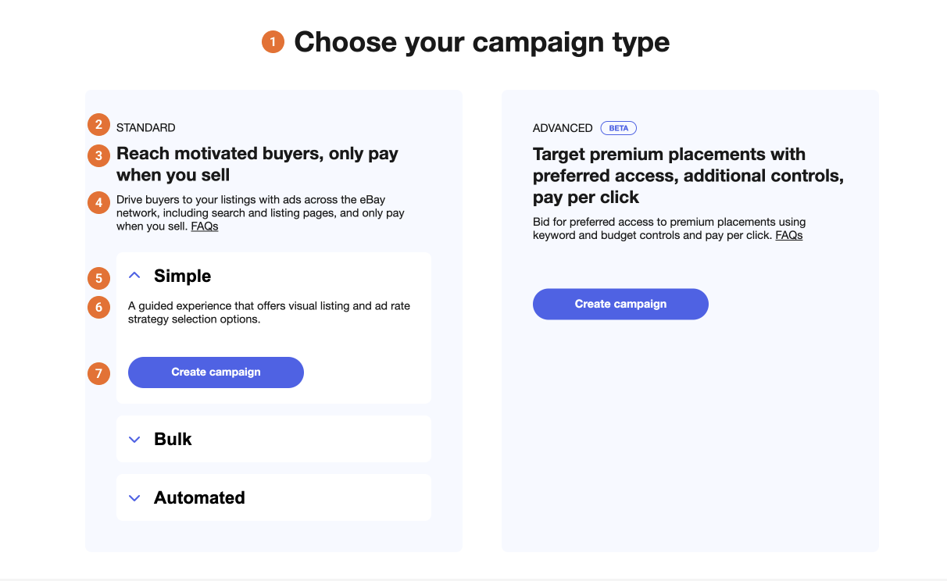
Simple flow - Screen 1/2
# | Position | Q3 23 | Notes
1 | Header | Create new campaign
2 | Section header | Name your campaign
3 | Input box | Campaign Name
4 | Character limit | <x>/80
5 | Section header | Set your dates
6 | Input box | Start date
7 | Input box | End date
8 | Right rail header | Performance (NEW)
9 | Right rail subhead | Your estimated impression share
10 | Supporting text | Please select your ad rate strategy and listings to populate the impression share estimate.
11 | Section header | Choose your ad rate strategy
12 | Subcopy | You're in control. Choose how you'd like your ad rate to be set up - dynamic or fixed. An ad rate is the percentage of an item's total sale amount (including item price shipping, taxes, and any other applicable fees) that is charged when a buyer clicks one of your Standard ads and then purchases any of your Promoted Listings Standard items within 30 days.
13 | Option | Dynamic ad rate RECOMMENDED
14 | Subcopy | Stay competitive with an updated ad rate that automatically adjusts to eBay's daily suggestion.
15 | Option | Fixed ad rate
16 | Subcopy | Keep a consistent ad rate that will not change once it is set. You can always edit the ad rates at a later time.
17 |  | Customize
18 | Checkbox | Set ad rate cap
19 | Checkbox | Adjust dynamic ad rate
20 | Marketing Program Terms | By launching your campaign, you agree to the Marketing Program Terms.
21 |  | <x> listings selected
22 | Secondary CTA | Cancel
23 | CTA | Launch
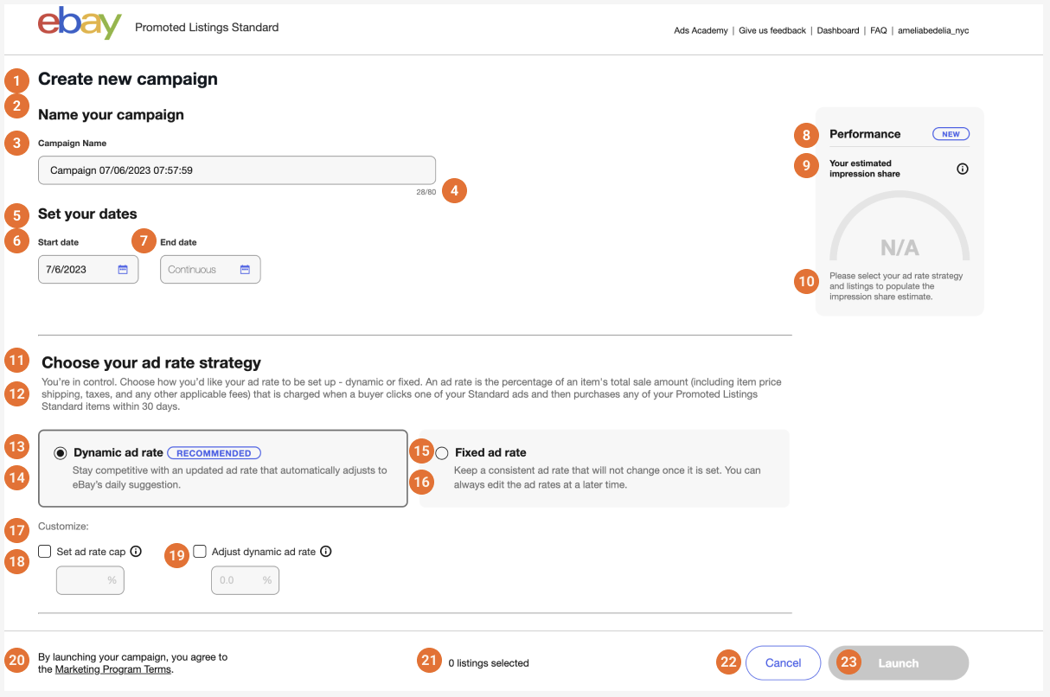
Simple flow - Screen 2/2
# | Position | Q3 23 | Notes
1 | Header | Select your listings
2 | Subhead | Use filters to select your listings.
3 | Input box | Categories
4 | Input box | Price
5 | Input box | From $
6 | Input box | to $
7 | Input box | Brand
8 | Input box | Condition
9 | Input box | More filters
10 |  | Reset all
11 | Input box | Quick filters
12 | Filter suggestion | Recommended listings
13 | Section header | Showing 1 - <x> of <x> listings
14 | Toggle | Show selected listings only
15 |  | Clear listing selections
16 | Column | Title
17 | Column | Price
18 | Column | Qty
19 | Column | Days on site
20 | Column | Today's suggested ad rate
21 | Column | Your Ad rate
22 | Page number | X
23 | Dropdown | Items per page
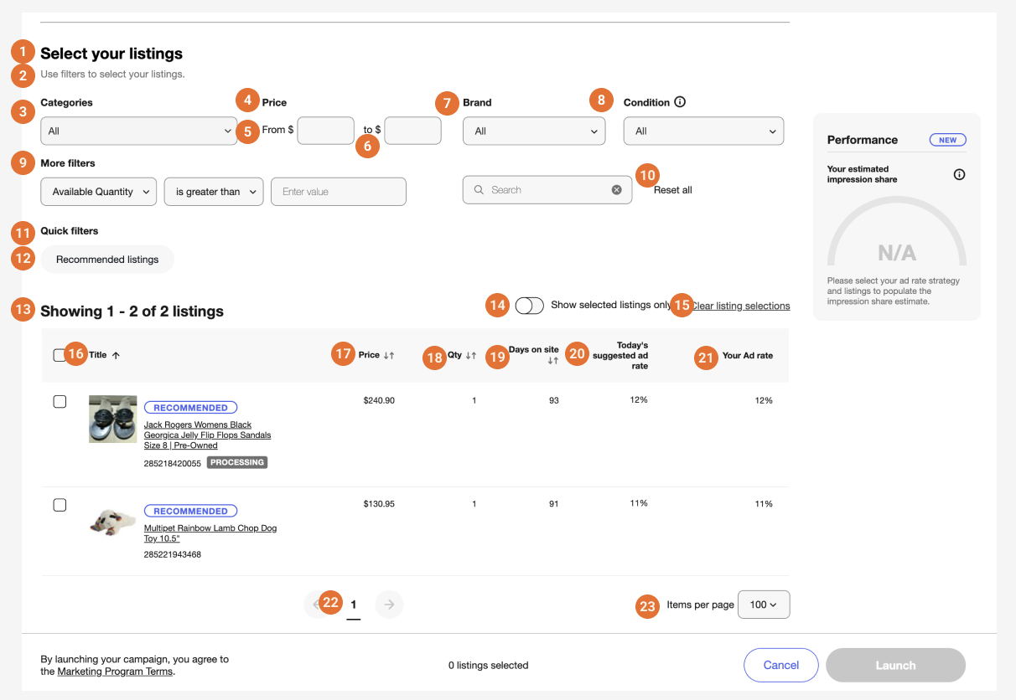
Simple flow - Screen with forecasting info bubble
# | Position | Q3 23 | Notes
 | Forecasting bubble copy | A feature that helps you predict how likely your ad is to be seen by comparing your ad rate with the maximum number of impressions your ad could have. The higher your ad rate, the higher your likelihood to reach buyers.  Results are directional and do not guarantee performance.
